* Multiplicity / The Wanderer
  + Clones and identically equipped
  + Half wounds /low toughness
  + Dies all at once
    - Perhaps via a wound pool
* Hive
  + Consider renaming this. I don’t want it to seem like an insect faction necessarily. Too close to Beetle Knights. Maybe some kind of crystal
  + Being without a certain proximity shares all powers
  + Combination of Slivers and Tyranid Synapse
  + I like the idea of chaining effects through ALL guys in range of the chain. Makes positioning and risk assessment a big ask, in exchange for high power concentration
* Arcana
  + Elementals and living spells
  + Elementals
    - Need their own type of element on terrain to spawn/teleport
    - Terrain manipulation
      * Leaving behind fire
* Beetle Knights
  + -Maybe roll into Hive?
  + -High value, high quality
* Shroomin
  + Low-cost, swarm faction
  + On-death effects (spores)
    - Perhaps can spawn new guys from units exposed to spores
  + Spores stack for increased effect
* CaveBeasts
  + High power, high toughness, average cost
  + Blind, relies on tremorsense
    - Perhaps it can only move 1/2M unless an enemy ends its move within X (maybe M?) distance
      * This is to represent that they are blind and keeps the player from metagaming too hard
* Fleshcrafters
  + High customization level
    - Create-a-creature faction.
  + Can go big or go wide, but pays for it SOMEHOW
    - Figure out this penalty
      * So far it seems to be average base-cost units, with increasingly-inefficient unit costs for higher levels
  + High degree of reliance on the relatively-squishy Fleshcrafter Priest for support and survivability
* Plant dudes
  + Slow, high toughness and wounds, regen access
  + Clones via root/seed mechanic. Splits wounds with new unit
    - Perhaps can only do once
  + Makes root clusters(like creep tumors)
  + While in cluster, gets some sort of bonuses or abilities
    - Can distribute wounds along the root system to mitigate damage

**MECHANICS**

* Stats
  + Move Cost
    - The cost paid per inch of movement
  + Attack Cost
    - The cost per attack
  + Wounds
    - The amount of damage the unit can sustain before it dies
  + Toughness
    - Represents the unit’s physical toughness. Opposes power. This is the hardiness of the unit.
  + Power
    - The unit’s strength. Used to oppose toughness
  + Activation Points
    - Used to pay costs for Attack, Movement, and Ability actions. Replenishes at the start of each Round
  + Focus
    - Used to pay for special actions and events. Replenishes at the start of each Round.
* Actions
  + There are three types of actions
  + Attack
    - Represents a single attack by a model
  + Movement
    - The unit can move up to X inches, where X is (points spent)/(Movement Cost) rounded down
  + Ability

GAME FLOW

* Pre game actions
* Battle round
  + Beginning of round events
  + Turn sequence
    - Players take turns alternating
    - Each unit may take a move, attack, and ability action. They may take any, but if activated must take at least one.
      * This is to prevent shenanigans wherein people activate models without using them to draw out time.
  + End of round events
    - Event Triggers
      * This is where “End of Round” events happen
    - State check
      * Objective control is checked
      * Points are accumulated
      * Activation Points and Focus are restored
* Battle end
  + End of game events
  + Score/victory calculation
* **Actions**
  + GENERAL RULES
    - Units may select and execute one action at a time OR they may combine multiple actions into a single execution. All costs for Actions are paid prior to the Action’s execution. Activation Point cost totals are always rounded unless otherwise specified
    - Each Action type may be selected only once per Activation of a unit
      * A player may select a Movement, Attack, or Ability Action to use
    - Action Sequence
      * Announce Action and targets
      * Pay costs
      * Trigger events
      * Execute all specified Actions one-by-one
    - **Movement**
      * Each unit may expend an amount of Activation Points equal to its Movement Cost to move that many inches
      * ADDITIONAL RULES
        + Movement Penalty Level

This is 0 unless otherwise specified.

For each level, increase the cost of a unit’s Movement by 50% of the base cost.

Example

Unit with 12 Activation Points and a Movement Cost of 1 moves through 5 inches of Difficult Terrain.

The cost of the 5 inches increases to 7.5, which rounds to 8. Which leaves 4 points available after the movement

* + - * + Attacks of Opportunity

A unit starting its Movement within an enemy’s Attack Range, but finishing without is subject to Attacks of Opportunity for each of those enemy units until the completion of the move.

This can be circumvented by increasing the Movement Penalty Level by 1 until the moving unit leaves the Attack Range.

Each of those enemy (Player B) units may expend Focus to take an immediate Attack action against the moving unit. All Attackers must be declared simultaneously.

The Focus cost is equal to the number of units controlled by the Active Player that have Melee Range on the Attacking unit

* + - * Difficult terrain
        + When moving over difficult terrain, a unit must expend twice the Activation Points per inch of movement.
    - **Attack**
      * Attacks are executed one at a time
      * Damage is calculated by subtracting X from the Attacker’s Power, where X = Defender’s Toughness - Attacker’s Power. This cannot reduce an Attack to fewer than one point of Damage, nor can it increase an Attack’s damage. Mitigation Abilities are then applied.
        + Example 1

Attacker: Power 3

Defender: Toughness 4

Difference is 1, so total damage is 3 -1 => 2

* + - * + Example 2

Attacker: Power 4

Defender: Toughness 3

Difference is -1, but damage cannot be increased this way normally

* + - * + Example 3

Attacker: Power 3

Defender: Toughness 7

Difference is 4, so total damage is 3 - 4 => 1

Remember that damage cannot go below 0 this way

* + - * Subtract the total Damage from the Defender’s Wound stat. If it is less than or equal to zero, the Defender unit is killed.
      * Repeat until all attacks are resolved.
      * *Additional Rules*
        + Attack Penalty Level

Starts at 0 unless otherwise specified

For each level, increase the cost of Attacks by 50% of the base Attack Cost

* + - **Abilities**
* **Victory Conditions**
  + A Player wins when they either achieve the Mission’s Victory Conditions or are the last remaining Force on the Battlefield.
  + Capturing Objectives
    - To capture an Objective, a unit must end the Round within Capture Range (2 inches) of it.
    - If multiple Players are within Capture Range of the Objective, control is granted to the player who controls at least ⅔ of the total units within Capture Range. If nobody meets this criteria, the Objective is considered to be Contested.
* **Universal Special Rules**
  + Dodge
    - Applies an Attack Penalty Level to each Attack against this unit
  + Armor X
    - Mitigation Ability
    - Reduces incoming Damage by X
  + Relentless X
    - Ignores the first X levels of Attack Penalties
  + Undaunted X
    - Ignores the first X levels of Movement Penalties
  + Regeneration X
    - The unit restores X Wounds at the end of each Round
  + Blind
    - The unit receives two Movement Penalty Levels, and Ranged Attacks have their maximum range reduced by 75%

Setting Information

Overall themes and ideas

This is meant to reflect a strange vision of a world far beyond the traditional “end of the world” scenario. It’s a post-post-apocalyptic fantasy setting. By design, the themes are meant to be unfamiliar or unsettling. While some setting information and history is provided, remember that it needn’t necessarily be taken as 100% true canonically. All the history provided serves as an explanation for the state of things, so some personal variations are only sensible if it makes the game more fun for the player.

Basic Setting

Millions of years in the future, a world that was once very much like ours has become a very unfamiliar place, populated by unrecognizable creatures and beings driven by strange motivations. The Earth, the physical realm, and the spiritual realms are bound together by arcane energy, which flows between both worlds and binds them. <FILL THIS IN MORE!!!!!>

# Factions

Arcanum

Lorem ipsum dolor sit amet, consectetur adipiscing elit. Aliquam varius ligula vel tempor eleifend. Mauris nunc nulla, aliquam ac euismod at, bibendum sed sapien. Aenean nec condimentum odio. Pellentesque mauris nunc, mollis eu consectetur vitae, lobortis et ex. Aliquam pharetra, odio sit amet viverra pulvinar, velit velit rhoncus mi, et facilisis erat tortor quis risus. Quisque cursus congue sapien vel bibendum. Class aptent taciti sociosqu ad litora torquent per conubia nostra, per inceptos himenaeos. Quisque porttitor gravida condimentum. Mauris vel sollicitudin arcu. Nam eleifend dignissim libero egestas mollis. Phasellus nisi risus, viverra consequat eros quis, faucibus rhoncus massa. Cras vel leo eros.

Sed vitae ligula dapibus, interdum neque at, malesuada enim. Cras vitae nibh et libero vehicula euismod quis vel magna. Maecenas risus diam, sagittis sit amet ultrices non, hendrerit at nibh. Curabitur viverra elit vel ipsum laoreet, id hendrerit dui fringilla. Aenean finibus neque at nunc porttitor viverra. Ut facilisis ornare ex at interdum. Sed tristique, ante ac suscipit pulvinar, velit tellus placerat ligula, sed imperdiet nisi odio nec diam. Donec enim nisi, fermentum vel libero vulputate, aliquet condimentum odio. Phasellus faucibus interdum mi, nec hendrerit magna consequat quis. Mauris eget metus a nisl varius iaculis. Donec vulputate ligula vel justo tempus hendrerit. In enim augue, rutrum non pellentesque at, egestas ut ipsum. Phasellus auctor mi ut leo malesuada egestas. Vivamus in pellentesque orci, ac pulvinar mi. Curabitur vitae dictum velit.

Vestibulum nec sagittis nibh, in maximus ipsum. Suspendisse potenti. Nam non purus a magna convallis varius. Suspendisse sed felis lacus. Sed nisl massa, placerat vel est vitae, tristique dignissim dolor. Quisque feugiat sagittis lectus, ac porttitor est lobortis sed. Proin pellentesque eu erat non malesuada. Quisque fringilla in elit porta vehicula. Curabitur vel tincidunt urna. Suspendisse porta pharetra libero, sed placerat lectus pellentesque at. In sceleris

SOME COOL PICTURE OF THE ELEMENTALS

Fleshcrafter Priests

The Fleshcrafter Priests and their fetid fields are all that remains of the shattered glory of the once-great legacy of Man. Millions of years before the present day in-game, mankind reached a societal zenith thanks to his understanding of the arcane arts. Men had learned to access and use the magical energies in “ley lines” flowing unseen through the world. Over thousands of years of use, man slowly evolved to become more linked to this energy - and to one another. People began exhibiting minor telepathic innate abilities, as well as increased rates of mutation and arcane abilities. However, not all humans had the same degree of faith in the increasingly-unstable lines of energy. These Biomancers avoided touching leyline energy directly, instead focusing on healing and augmentative spells. Biomancy involved the use of “Animus”, or the human spirit. The human spirit had become so intertwined with the leylines that mankind’s Animus itself became a source of power. By accessing the latent energies within a person or within themselves, they could perform great feats of restoration and enhancement.

At one point, man went too far in his search for knowledge and power. In an experiment gone awry, the Animus-leyline bridge was overwhelmed and the undercurrents of magic merged with the Animus of man. Instantly, virtually all the souls of the human race were merged into a giant collective, streaming and flowing through the leylines. The human’s bodies were warped and disfigured by the overwhelming amount of energy coursing through them. The lucky ones died instantly, while some were morphed into piles of barely-functional flesh or soul-less husks in the shape of men. Due to their high degree of connection to the elements and leylines, many people fused with the Earth itself. Instead of grass, dirt, and trees there were endless fields of hair, flesh, and bone. Not all was lost though.

The greatest of the Biomancers had managed to protect themselves through limited leyline access and mastery of Animus, though they weren’t completely unaffected. They emerged from their protective warrens and shelters to a nightmare world they could barely fathom, driving many of them to madness. Realizing that they and other scattered conclaves were likely the only remains of the human race, they set to trying to fix things. Though they hadn’t been reconstituted or stripped of their Animus, the Biomancers found that their prior abilities were far stronger. They found that they could easily reshape the living terrain that had once been their people back into men, but the results were hollow. The restored bodies were lacking virtually all Animus, and so were little more than unthinking animals. A man couldn’t be created unless a complete Animus was gathered. Nonetheless, they pushed on, until a curious discovery was made; the Biomancers didn’t age. Initially this seemed to be a boon. What had been a problem constrained to decades now became open-ended. Unable to access the leylines, and with no immediate solution they settled in and began their long work. The decades turned to centuries, and the centuries turned to millennia. At first they tried to remain the remnants of their old civilization. But with such limited numbers and abilities, they inevitably failed. With no masons, the buildings crumbled. With no craftsman, the ability to produce even pig iron began to fade. Eventually the distasteful decision was made to begin utilizing the flesh fields for labor and resources. Countless millennia dragged on, taking a constant toll on the shrinking remnants of the human race. An eternity of memories and almost constant failure drove almost all of them to madness. Their duties became rites and their mission a catechism. No longer mages or academics, they became Priests. And thus we arrive at the present.

The domains of the Fleshcrafter Priests are the stuff of nightmares. Endless fields of writhing flesh. Prairies of hair filled with enormous parasites. Misshapen mouths open and close mindlessly, eager to devour anything that approaches. The Flesh Fields are filled with the steady hum and drone of thousands of mouths crying, groaning, and whimpering. The regions are also patrolled by all sorts of abominations and twisted creatures tailor-made by the Priests to defend their territories. The Priests themselves are almost to a man completely mad. None seem to recall what mankind looked like, or how the state of things came to be. All that persists is the desire to restore humanity. While the individual Priest’s goals and means may vary; the most common means are via growing the fields, acquiring biomass and harvesting Animus to attempt to recreate souls.

Fleshcrafter Priest

|  |  |  |  |  |  |  |  |
| --- | --- | --- | --- | --- | --- | --- | --- |
| MC | AC | T | P | W | A | F | Cost |
| 1 | 3 | 4 | 4 | 14 | 0 | 4 | 25 |

**Abilities:** Spellcaster: Fleshcraft,

*Adaptable*: When selecting this model, you may pay 10 +(X*5) additional points, where X = (current Reshape level -1) to increase this model's Reshape level by one. This ability may be used multiple times, but it must be used one use at a time. (IE: You must upgrade from Reshape 1 to Reshape 2 to Reshape 3. You cannot upgrade directly from Reshape 1 to Reshape 3)

Lorem ipsum dolor sit amet, consectetur adipiscing elit. Aliquam varius ligula vel tempor eleifend. Mauris nunc nulla, aliquam ac euismod at, bibendum sed sapien. Aenean nec condimentum odio. Pellentesque mauris nunc, mollis eu consectetur vitae, lobortis et ex. Aliquam pharetra, odio sit amet viverra pulvinar, velit velit rhoncus mi, et facilisis erat tortor quis risus. Quisque cursus congue sapien vel bibendum. Class aptent taciti sociosqu ad litora torquent per conubia nostra, per inceptos himenaeos. Quisque porttitor gravida condimentum. Mauris vel sollicitudin arcu. Nam eleifend dignissim libero egestas mollis. Phasellus nisi risus, viverra consequat eros quis, faucibus rhoncus massa. Cras vel leo eros.

Sed vitae ligula dapibus, interdum neque at, malesuada enim. Cras vitae nibh et libero vehicula euismod quis vel magna. Maecenas risus diam, sagittis sit amet ultrices non, hendrerit at nibh. Curabitur viverra elit vel ipsum laoreet, id hendrerit dui fringilla. Aenean finibus neque at nunc porttitor viverra. Ut facilisis ornare ex at interdum. Sed tristique, ante ac suscipit pulvinar, velit tellus placerat ligula, sed imperdiet nisi odio nec diam. Donec enim nisi, fermentum vel libero vulputate, aliquet condimentum odio. Phasellus faucibus interdum mi, nec hendrerit magna consequat quis. Mauris eget metus a nisl varius iaculis. Donec vulputate ligula vel justo tempus hendrerit. In enim augue, rutrum non pellentesque at, egestas ut ipsum. Phasellus auctor mi ut leo malesuada egestas. Vivamus in pellentesque orci, ac pulvinar mi. Curabitur vitae dictum velit.

Vestibulum nec sagittis nibh, in maximus ipsum. Suspendisse potenti. Nam non purus a magna convallis varius. Suspendisse sed felis lacus. Sed nisl massa, placerat vel est vitae, tristique dignissim dolor. Quisque feugiat sagittis lectus, ac porttitor est lobortis sed. Proin pellentesque eu erat non malesuada. Quisque fringilla in elit porta vehicula. Curabitur vel tincidunt urna. Suspendisse porta pharetra libero, sed placerat lectus pellentesque at. In sceleris

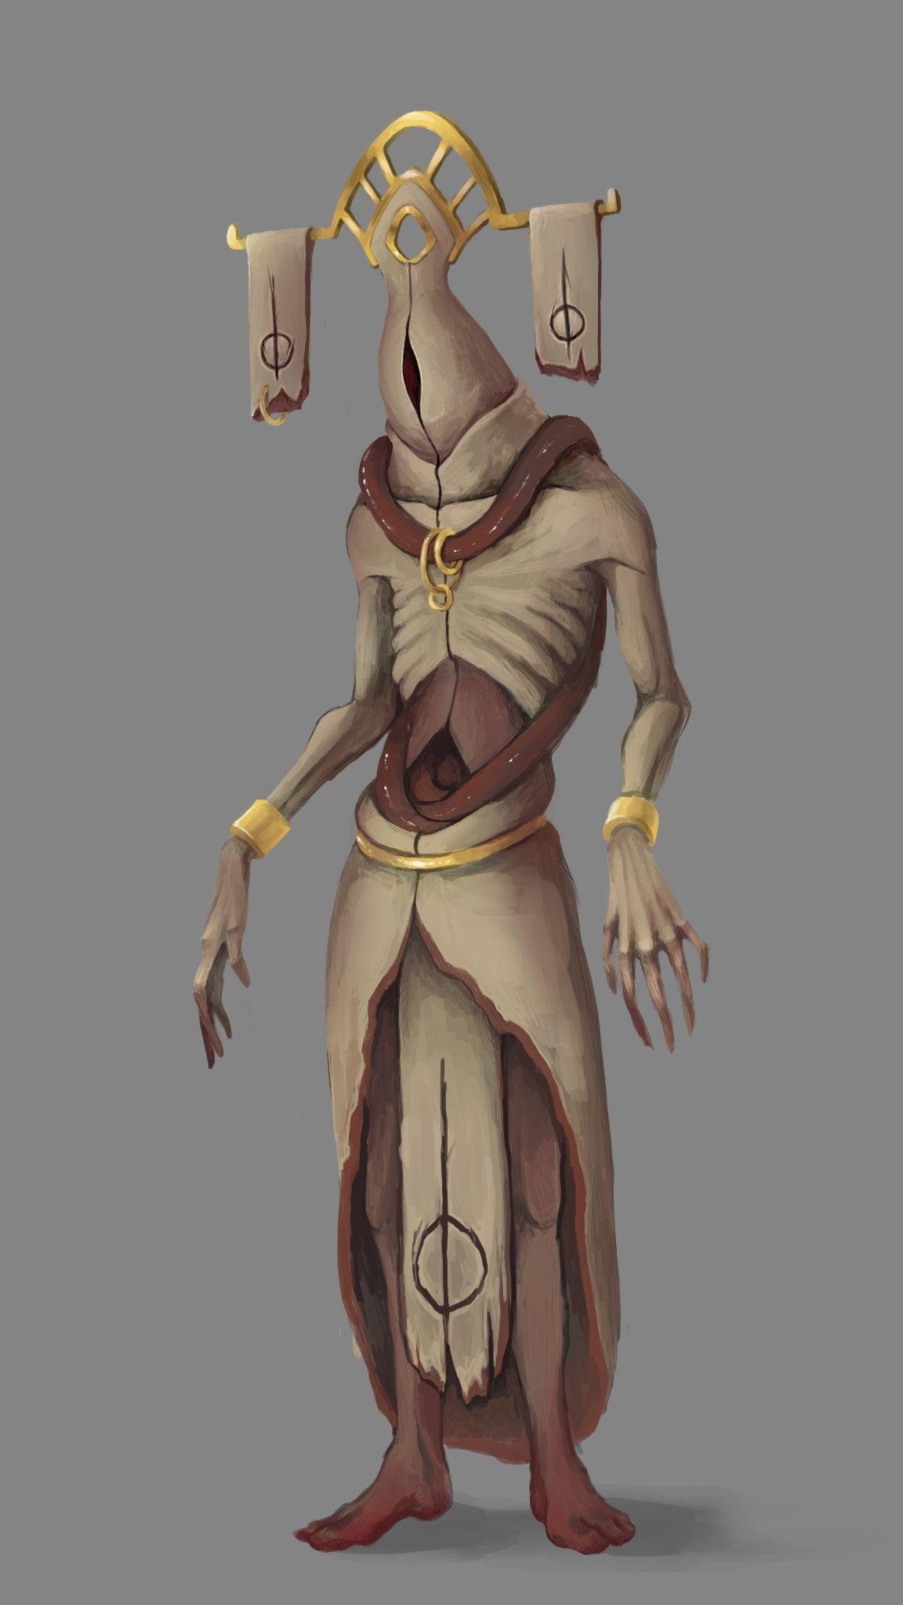

Flesh Pile

|  |  |  |  |  |  |  |  |
| --- | --- | --- | --- | --- | --- | --- | --- |
| MC | AC | T | P | W | A | F | Cost |
| 3 | - | 1 | 0 | 1 | 0 | 0 | - |

**Abilities:**

*Reshape 0*

Lorem ipsum dolor sit amet, consectetur adipiscing elit. Aliquam varius ligula vel tempor eleifend. Mauris nunc nulla, aliquam ac euismod at, bibendum sed sapien. Aenean nec condimentum odio. Pellentesque mauris nunc, mollis eu consectetur vitae, lobortis et ex. Aliquam pharetra, odio sit amet viverra pulvinar, velit velit rhoncus mi, et facilisis erat tortor quis risus. Quisque cursus congue sapien vel bibendum. Class aptent taciti sociosqu ad litora torquent per conubia nostra, per inceptos himenaeos. Quisque porttitor gravida condimentum. Mauris vel sollicitudin arcu. Nam eleifend dignissim libero egestas mollis. Phasellus nisi risus, viverra consequat eros quis, faucibus rhoncus massa. Cras vel leo eros.

Sed vitae ligula dapibus, interdum neque at, malesuada enim. Cras vitae nibh et libero vehicula euismod quis vel magna. Maecenas risus diam, sagittis sit amet ultrices non, hendrerit at nibh. Curabitur viverra elit vel ipsum laoreet, id hendrerit dui fringilla. Aenean finibus neque at nunc porttitor viverra. Ut facilisis ornare ex at interdum. Sed tristique, ante ac suscipit pulvinar, velit tellus placerat ligula, sed imperdiet nisi odio nec diam. Donec enim nisi, fermentum vel libero vulputate, aliquet condimentum odio. Phasellus faucibus interdum mi, nec hendrerit magna consequat quis. Mauris eget metus a nisl varius iaculis. Donec vulputate ligula vel justo tempus hendrerit. In enim augue, rutrum non pellentesque at, egestas ut ipsum. Phasellus auctor mi ut leo malesuada egestas. Vivamus in pellentesque orci, ac pulvinar mi. Curabitur vitae dictum velit.

Vestibulum nec sagittis nibh, in maximus ipsum. Suspendisse potenti. Nam non purus a magna convallis varius. Suspendisse sed felis lacus. Sed nisl massa, placerat vel est vitae, tristique dignissim dolor. Quisque feugiat sagittis lectus, ac porttitor est lobortis sed. Proin pellentesque eu erat non malesuada. Quisque fringilla in elit porta vehicula. Curabitur vel tincidunt urna. Suspendisse porta pharetra libero, sed placerat lectus pellentesque at. In sceleris



Flesh Drone

|  |  |  |  |  |  |  |  |
| --- | --- | --- | --- | --- | --- | --- | --- |
| MC | AC | T | P | W | A | F | Cost |
| 1 | 3 | 3 | 3 | 8 | 0 | 1 | 10 |

**Abilities:**

*Reshape 1*: The unit is malleable and can be recreated and changed by other units. X represents the current level.

Lorem ipsum dolor sit amet, consectetur adipiscing elit. Aliquam varius ligula vel tempor eleifend. Mauris nunc nulla, aliquam ac euismod at, bibendum sed sapien. Aenean nec condimentum odio. Pellentesque mauris nunc, mollis eu consectetur vitae, lobortis et ex. Aliquam pharetra, odio sit amet viverra pulvinar, velit velit rhoncus mi, et facilisis erat tortor quis risus. Quisque cursus congue sapien vel bibendum. Class aptent taciti sociosqu ad litora torquent per conubia nostra, per inceptos himenaeos. Quisque porttitor gravida condimentum. Mauris vel sollicitudin arcu. Nam eleifend dignissim libero egestas mollis. Phasellus nisi risus, viverra consequat eros quis, faucibus rhoncus massa. Cras vel leo eros.

Sed vitae ligula dapibus, interdum neque at, malesuada enim. Cras vitae nibh et libero vehicula euismod quis vel magna. Maecenas risus diam, sagittis sit amet ultrices non, hendrerit at nibh. Curabitur viverra elit vel ipsum laoreet, id hendrerit dui fringilla. Aenean finibus neque at nunc porttitor viverra. Ut facilisis ornare ex at interdum. Sed tristique, ante ac suscipit pulvinar, velit tellus placerat ligula, sed imperdiet nisi odio nec diam. Donec enim nisi, fermentum vel libero vulputate, aliquet condimentum odio. Phasellus faucibus interdum mi, nec hendrerit magna consequat quis. Mauris eget metus a nisl varius iaculis. Donec vulputate ligula vel justo tempus hendrerit. In enim augue, rutrum non pellentesque at, egestas ut ipsum. Phasellus auctor mi ut leo malesuada egestas. Vivamus in pellentesque orci, ac pulvinar mi. Curabitur vitae dictum velit.

Vestibulum nec sagittis nibh, in maximus ipsum. Suspendisse potenti. Nam non purus a magna convallis varius. Suspendisse sed felis lacus. Sed nisl massa, placerat vel est vitae, tristique dignissim dolor. Quisque feugiat sagittis lectus, ac porttitor est lobortis sed. Proin pellentesque eu erat non malesuada. Quisque fringilla in elit porta vehicula. Curabitur vel tincidunt urna. Suspendisse porta pharetra libero, sed placerat lectus pellentesque at. In sceleris

Flesh Golem

|  |  |  |  |  |  |  |  |
| --- | --- | --- | --- | --- | --- | --- | --- |
| MC | AC | T | P | W | A | F | Cost |
| 1 | 3 | 3 | 3 | 8 | 0 | 1 | 10 |

**Abilities:**

*Reshape 2*: The unit is malleable and can be recreated and changed by other units. X represents the current level.

Lorem ipsum dolor sit amet, consectetur adipiscing elit. Aliquam varius ligula vel tempor eleifend. Mauris nunc nulla, aliquam ac euismod at, bibendum sed sapien. Aenean nec condimentum odio. Pellentesque mauris nunc, mollis eu consectetur vitae, lobortis et ex. Aliquam pharetra, odio sit amet viverra pulvinar, velit velit rhoncus mi, et facilisis erat tortor quis risus. Quisque cursus congue sapien vel bibendum. Class aptent taciti sociosqu ad litora torquent per conubia nostra, per inceptos himenaeos. Quisque porttitor gravida condimentum. Mauris vel sollicitudin arcu. Nam eleifend dignissim libero egestas mollis. Phasellus nisi risus, viverra consequat eros quis, faucibus rhoncus massa. Cras vel leo eros.

Sed vitae ligula dapibus, interdum neque at, malesuada enim. Cras vitae nibh et libero vehicula euismod quis vel magna. Maecenas risus diam, sagittis sit amet ultrices non, hendrerit at nibh. Curabitur viverra elit vel ipsum laoreet, id hendrerit dui fringilla. Aenean finibus neque at nunc porttitor viverra. Ut facilisis ornare ex at interdum. Sed tristique, ante ac suscipit pulvinar, velit tellus placerat ligula, sed imperdiet nisi odio nec diam. Donec enim nisi, fermentum vel libero vulputate, aliquet condimentum odio. Phasellus faucibus interdum mi, nec hendrerit magna consequat quis. Mauris eget metus a nisl varius iaculis. Donec vulputate ligula vel justo tempus hendrerit. In enim augue, rutrum non pellentesque at, egestas ut ipsum. Phasellus auctor mi ut leo malesuada egestas. Vivamus in pellentesque orci, ac pulvinar mi. Curabitur vitae dictum velit.

Vestibulum nec sagittis nibh, in maximus ipsum. Suspendisse potenti. Nam non purus a magna convallis varius. Suspendisse sed felis lacus. Sed nisl massa, placerat vel est vitae, tristique dignissim dolor. Quisque feugiat sagittis lectus, ac porttitor est lobortis sed. Proin pellentesque eu erat non malesuada. Quisque fringilla in elit porta vehicula. Curabitur vel tincidunt urna. Suspendisse porta pharetra libero, sed placerat lectus pellentesque at. In sceleris

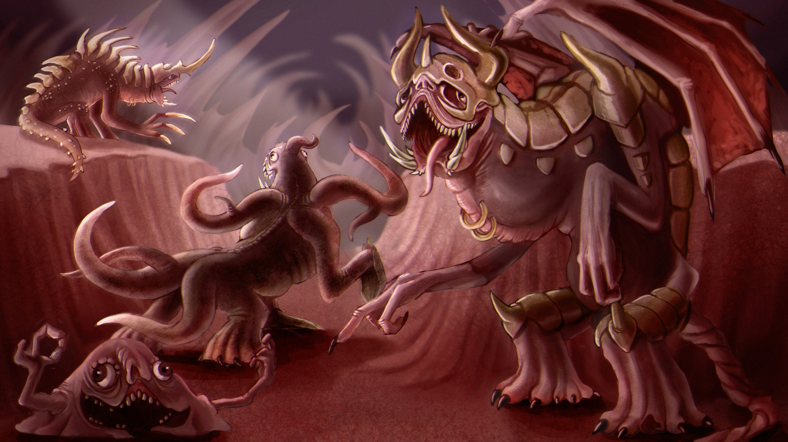

Flesh Behemoth

|  |  |  |  |  |  |  |  |
| --- | --- | --- | --- | --- | --- | --- | --- |
| MC | AC | T | P | W | A | F | Cost |
| 1 | 3 | 3 | 3 | 8 | 0 | 1 | 10 |

**Abilities:**

*Reshape 3*: The unit is malleable and can be recreated and changed by other units. X represents the current level.

Lorem ipsum dolor sit amet, consectetur adipiscing elit. Aliquam varius ligula vel tempor eleifend. Mauris nunc nulla, aliquam ac euismod at, bibendum sed sapien. Aenean nec condimentum odio. Pellentesque mauris nunc, mollis eu consectetur vitae, lobortis et ex. Aliquam pharetra, odio sit amet viverra pulvinar, velit velit rhoncus mi, et facilisis erat tortor quis risus. Quisque cursus congue sapien vel bibendum. Class aptent taciti sociosqu ad litora torquent per conubia nostra, per inceptos himenaeos. Quisque porttitor gravida condimentum. Mauris vel sollicitudin arcu. Nam eleifend dignissim libero egestas mollis. Phasellus nisi risus, viverra consequat eros quis, faucibus rhoncus massa. Cras vel leo eros.

Sed vitae ligula dapibus, interdum neque at, malesuada enim. Cras vitae nibh et libero vehicula euismod quis vel magna. Maecenas risus diam, sagittis sit amet ultrices non, hendrerit at nibh. Curabitur viverra elit vel ipsum laoreet, id hendrerit dui fringilla. Aenean finibus neque at nunc porttitor viverra. Ut facilisis ornare ex at interdum. Sed tristique, ante ac suscipit pulvinar, velit tellus placerat ligula, sed imperdiet nisi odio nec diam. Donec enim nisi, fermentum vel libero vulputate, aliquet condimentum odio. Phasellus faucibus interdum mi, nec hendrerit magna consequat quis. Mauris eget metus a nisl varius iaculis. Donec vulputate ligula vel justo tempus hendrerit. In enim augue, rutrum non pellentesque at, egestas ut ipsum. Phasellus auctor mi ut leo malesuada egestas. Vivamus in pellentesque orci, ac pulvinar mi. Curabitur vitae dictum velit.

Vestibulum nec sagittis nibh, in maximus ipsum. Suspendisse potenti. Nam non purus a magna convallis varius. Suspendisse sed felis lacus. Sed nisl massa, placerat vel est vitae, tristique dignissim dolor. Quisque feugiat sagittis lectus, ac porttitor est lobortis sed. Proin pellentesque eu erat non malesuada. Quisque fringilla in elit porta vehicula. Curabitur vel tincidunt urna. Suspendisse porta pharetra libero, sed placerat lectus pellentesque at. In sceleris

# FLESH BEHEMOTH IMAGE

Flesh Colossus

|  |  |  |  |  |  |  |  |
| --- | --- | --- | --- | --- | --- | --- | --- |
| MC | AC | T | P | W | A | F | Cost |
| 1 | 3 | 3 | 3 | 8 | 0 | 1 | 10 |

**Abilities:**

*Reshape 4*: The unit is malleable and can be recreated and changed by other units. X represents the current level.

Lorem ipsum dolor sit amet, consectetur adipiscing elit. Aliquam varius ligula vel tempor eleifend. Mauris nunc nulla, aliquam ac euismod at, bibendum sed sapien. Aenean nec condimentum odio. Pellentesque mauris nunc, mollis eu consectetur vitae, lobortis et ex. Aliquam pharetra, odio sit amet viverra pulvinar, velit velit rhoncus mi, et facilisis erat tortor quis risus. Quisque cursus congue sapien vel bibendum. Class aptent taciti sociosqu ad litora torquent per conubia nostra, per inceptos himenaeos. Quisque porttitor gravida condimentum. Mauris vel sollicitudin arcu. Nam eleifend dignissim libero egestas mollis. Phasellus nisi risus, viverra consequat eros quis, faucibus rhoncus massa. Cras vel leo eros.

Sed vitae ligula dapibus, interdum neque at, malesuada enim. Cras vitae nibh et libero vehicula euismod quis vel magna. Maecenas risus diam, sagittis sit amet ultrices non, hendrerit at nibh. Curabitur viverra elit vel ipsum laoreet, id hendrerit dui fringilla. Aenean finibus neque at nunc porttitor viverra. Ut facilisis ornare ex at interdum. Sed tristique, ante ac suscipit pulvinar, velit tellus placerat ligula, sed imperdiet nisi odio nec diam. Donec enim nisi, fermentum vel libero vulputate, aliquet condimentum odio. Phasellus faucibus interdum mi, nec hendrerit magna consequat quis. Mauris eget metus a nisl varius iaculis. Donec vulputate ligula vel justo tempus hendrerit. In enim augue, rutrum non pellentesque at, egestas ut ipsum. Phasellus auctor mi ut leo malesuada egestas. Vivamus in pellentesque orci, ac pulvinar mi. Curabitur vitae dictum velit.

Vestibulum nec sagittis nibh, in maximus ipsum. Suspendisse potenti. Nam non purus a magna convallis varius. Suspendisse sed felis lacus. Sed nisl massa, placerat vel est vitae, tristique dignissim dolor. Quisque feugiat sagittis lectus, ac porttitor est lobortis sed. Proin pellentesque eu erat non malesuada. Quisque fringilla in elit porta vehicula. Curabitur vel tincidunt urna. Suspendisse porta pharetra libero, sed placerat lectus pellentesque at. In sceleris

Flesh Titan

|  |  |  |  |  |  |  |  |
| --- | --- | --- | --- | --- | --- | --- | --- |
| MC | AC | T | P | W | A | F | Cost |
| 1 | 3 | 3 | 3 | 8 | 0 | 1 | 10 |

**Abilities:**

*Reshape 5*: The unit is malleable and can be recreated and changed by other units. X represents the current level.

Lorem ipsum dolor sit amet, consectetur adipiscing elit. Aliquam varius ligula vel tempor eleifend. Mauris nunc nulla, aliquam ac euismod at, bibendum sed sapien. Aenean nec condimentum odio. Pellentesque mauris nunc, mollis eu consectetur vitae, lobortis et ex. Aliquam pharetra, odio sit amet viverra pulvinar, velit velit rhoncus mi, et facilisis erat tortor quis risus. Quisque cursus congue sapien vel bibendum. Class aptent taciti sociosqu ad litora torquent per conubia nostra, per inceptos himenaeos. Quisque porttitor gravida condimentum. Mauris vel sollicitudin arcu. Nam eleifend dignissim libero egestas mollis. Phasellus nisi risus, viverra consequat eros quis, faucibus rhoncus massa. Cras vel leo eros.

Sed vitae ligula dapibus, interdum neque at, malesuada enim. Cras vitae nibh et libero vehicula euismod quis vel magna. Maecenas risus diam, sagittis sit amet ultrices non, hendrerit at nibh. Curabitur viverra elit vel ipsum laoreet, id hendrerit dui fringilla. Aenean finibus neque at nunc porttitor viverra. Ut facilisis ornare ex at interdum. Sed tristique, ante ac suscipit pulvinar, velit tellus placerat ligula, sed imperdiet nisi odio nec diam. Donec enim nisi, fermentum vel libero vulputate, aliquet condimentum odio. Phasellus faucibus interdum mi, nec hendrerit magna consequat quis. Mauris eget metus a nisl varius iaculis. Donec vulputate ligula vel justo tempus hendrerit. In enim augue, rutrum non pellentesque at, egestas ut ipsum. Phasellus auctor mi ut leo malesuada egestas. Vivamus in pellentesque orci, ac pulvinar mi. Curabitur vitae dictum velit.

Vestibulum nec sagittis nibh, in maximus ipsum. Suspendisse potenti. Nam non purus a magna convallis varius. Suspendisse sed felis lacus. Sed nisl massa, placerat vel est vitae, tristique dignissim dolor. Quisque feugiat sagittis lectus, ac porttitor est lobortis sed. Proin pellentesque eu erat non malesuada. Quisque fringilla in elit porta vehicula. Curabitur vel tincidunt urna. Suspendisse porta pharetra libero, sed placerat lectus pellentesque at. In sceleris

